SAULT COLLEGE OF APPLIED ARTS AND TECHNOLOGY

SAULT STE. MARIE, ONTARIO

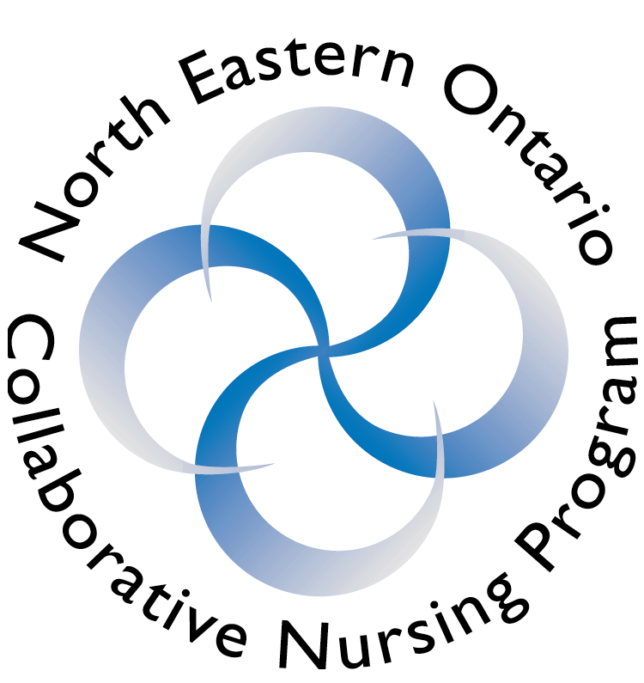

COURSE OUTLINE

COURSE TITLE: | Health I: Self and Family Health
CODE NO. : | NURS1006 |  | SEMESTER: | 1
PROGRAM: | Collaborative BScN
AUTHOR: | Linda Chow, Marilyn King, Joanne Carbonneau, Theresa Mirka,  Mary Lou Trowell
DATE: | Sept/01 | PREVIOUS OUTLINE DATED: |  |  | N/A
APPROVED:
 | __________________________________  DEAN |  |  |  | ____________  DATE
TOTAL CREDITS: | 3
PREREQUISITE(S):  EQUIVALENCIES: | None  None
HOURS/WEEK: | 3 (classroom), 4 (Lab), 4 (Clinical 2nd half of semester)

Copyright © 2001 The Sault College of Applied Arts & Technology
Reproduction of this document by any means, in whole or in part, without prior

written permission of Sault College of Applied Arts & Technology is prohibited.

For additional information, please contact Judi Maundrell, Dean
School of Health and Human Services
(705) 759-2554, Ext. 603/689

I. | COURSE DESCRIPTION:  The major emphasis of this course is on the personal meaning of health, related health assessments and health maintenance. Learners will examine significant theoretical and conceptual frameworks of health in relation to self and family. A community clinical experience will take place in the context of resource family. An agency based clinical experience will take place in the context of well elderly. By reflecting and reconstructing personal experiences, learners will have an opportunity to identify resources and challenges that affect health and recognize the complexity of the change process as related to health promotion and caring. (3 hours of class per week, 4 hours of lab per week, total community clinical hours 10, total agency hours 24).

II. | LEARNING OUTCOMES AND ELEMENTS OF THE PERFORMANCE:
ENDS-IN-VIEW:

This course will provide learners with opportunities to develop heightened awareness of their own personal concepts of health and healthy living. They will also have opportunities to become aware of differences in beliefs, values , and perceptions about health held by others and how these differences influence the way people behave, throughout the lifespan, in relation to health. Learners will have opportunities to explore the complexities of the change process in relation to transitions in the life cycle and in healthful living practices. Opportunities to learn basic health assessment skills will be included in this course.

PROCESS:

In order to develop a conceptual and experiential understanding of the concepts and theories in this course, learners will be provided with learning activities in which they will need to personally engage. Experiences arising from learning activities will be shared with others in active dialogue so that people’s experiences with health can be considered from praxis perspective. The teacher’s responsibility is to guide and facilitate; the learner’s responsibility is to use resources and to actively engage in dialogue and in the process of learning.

III. | TOPICS:  Through the use of a variety of learning activities, course content will reflect the following concepts::   the lived experience of the person (phenomenology), differing realities, self esteem, self concept, personal resources.   perception - personal meaning, personal construct theory, beliefs and values   context - culture, family, community, situatedness   responsibility - choice, self-responsibility   assessment - individual and family assessment process (beginning level), assessment in decision-making process.   empowerment/enablement - teaching , learning process.   transitions - developmental change, change theory, lifestyle change   ways of knowing - ethics of health, personal experiences, empirical knowledge (including Nursing research), theoretical knowledge.  Laboratory learning activities will be organized around the following concepts:  ASEPSIS -principles of; hand washing; gloving, standard precautions  ASSESSMENT -general assessment, temperature; pulse; respirations; blood pressure; height & weight.  MOBILITY -basic body mechanics; moving & transferring; R.O.M.; assisting with ambulation.  HYGIENE -bathing techniques; mouth care; bed-making; assisting with dressing  ELIMINATION -using assistive devices to promote urinary and bowel elimination; specimen collection  NUTRITION -feeding techniques; Intake & Output (I & O)

IV. | REQUIRED RESOURCES/TEXTS/MATERIALS:  Edelman, C.L. & Mandle, C.L. (1998). Health promotion throughout the lifespan. (4th ed.) St. Louis: C. V. Mosby.  Fuller, J. & Schaller-Ayers, J. (2000). Health assessment: A nursing approach (3rd ed.). Philadelphia: Lippincott.  North Eastern Ontario Collaborative Nursing Program Faculty. (2001). Learning activities and lab manual. Sudbury: Cambrian College.  Perry, A. & Potter, P. ( 2001). Clinical nursing skills and techniques (5th ed.). Toronto; C. V. Mosby.  Potter, P. and Perry, A. (2001). Canadian fundamentals of nursing (2nd ed.). Toronto: Mosby Year-Book.  American Psychological Association. (2001). Publication manual of the American Psychological Association (5th ed.). Washington, DC: American Psychological Association.  Selected reading and articles (see learning activities)  Laboratory and practice labs. (see laboratory manual)

V. | EVALUATION PROCESS/GRADING SYSTEM:  Successful completion of NURS1006 is dependent upon a satisfactory clinical status and 60% academic in the following:  1. Completion and documented evidence of a minimum of three (3) family visits to your resource family. Clinical grades are satisfactory/unsatisfactory. FAILURE TO COMPLETE VISITS PRIOR TO THE EXAMINATION PERIOD WILL RESULT IN AN UNSUCCESSFUL CLINICAL GRADE FOR NURS 1006 AND A FAILURE IN THE COURSE.  2. Regular attendance at laboratory sessions and practice labs (these are mandatory)

3. Reflective Journals

Each of the learning activities asks that you reflect and build upon your learning by addressing specific questions or ideas in a journal. (“In reflection”) we will discuss the format for these in the first class. You are not required to hand these in; however, you must complete these each week as the critical questions formulate the basis for the final examination.

4. Paper:

You are to choose a topic regarding an experience in health. Your topic may be one of the concepts studied in class. This may be a personal story such as your experience of leaving home for College (time/transitions), your family’s experience of the birth of a child or death of a loved one, ( time/transitions, ways of knowing), differences in culture in perception (context/culture) or how you came to learn a very important lesson (time/transition, personal knowledge, ways of knowing). You are to relate your story, discuss current literature related to your topic and formulate how this experience will influence your nursing career. You must submit two (2) copies of your paper for grading. I will return one and keep one on file. All papers are to be submitted at the beginning of class on the due date. This is a formal referenced paper worth 20% of your final grade. The paper is to be 4 - 6 pages in length. The criteria for the paper will be discussed in class.

5. Poster - “Adopt-a-School Project”

You will be assigned in pairs to visit a school in Sudbury. After visiting the school you will do a school profile or description. Based on identified needs in an assigned classroom in this school, you will prepare a health promotion activity poster that you will present for review by your facilitator in a lab period. After this review you will return to the school to present your poster. Further criteria and instructions will be given in class. This poster will be assessed as 10% of your final course grade.

6. Family Assessment:

Using your resource family, you will perform a family assessment, at a beginning level. You will use the “Family Assessment Tool” on page 147 in your Potter & Perry text. Start your paper with a description of your family (paint a picture in my mind of what they look like). Include the collected data using the tool in the text as a guide. After analyzing the collected data, develop health promotion strategies for your family. You must submit two copies of your paper for grading. I will return one and keep one on file. All papers are to be submitted at the beginning of class on the due date. This assignment is worth 25% of your final grade.

7. Lab test:

A test will be administered during a lab period in week 6. This test will address the material covered in lab periods and will be a combination of multiple choice and short answer questions. It is worth 10% of the final grade.

8. Final Examination:

You will write a final examination during the scheduled exam period at the end of the first term. This will be a combined multiple choice and essay type exam worth 35% of your grade. The content of the exam will comprehensive, drawing upon both your laboratory and classroom learning.

9. Institution-Based Clinical Experience: Well Elderly

During the latter 6 weeks of the term, you will complete 4 hours of clinical each week for a total 24-hour clinical experience. Clinical is mandatory and will be assessed as either “satisfactory” or “unsatisfactory”.

You may be developing a Clinical portfolio to be submitted to your clinical facilitator for evaluation. Further, you will engage in reflective practice to critique your clinical performance with respect to the five domains of Nursing. These will be discussed in depth at the beginning of the clinical experience by your clinical facilitator. NOTE: In order to obtain a passing grade in Self and Family Health, you must achieve a “satisfactory” clinical evaluation from your clinical facilitator.

This 24-hour clinical experience will provide opportunities for you to begin your practice of nursing. It is the intent that you will become an active participant in the construction of your own knowledge as you relate course concepts to your practice. You will have opportunities to practise professionally, to promote a safe and supportive environment , and to develop caring relationships as you engage with well elderly in an agency setting. A faculty member will serve as a learning facilitator and resource for your clinical group activities. It is hoped that you will develop an understanding of the complexity of relationships within families, and an ability to be sensitive to different family dynamics. In consultation with your clinical facilitator, you will be responsible for seeking opportunities to consolidate classroom and laboratory learning in the practice setting with respect to establishing a healing environment (i.e., listening, comforting, bed making); promoting exercise and movement (i.e. assisting with mobility, transferring, range of motion exercises) and providing comfort (i.e. bathing, skin care, oral hygiene, assisting with dressing, assisting with elimination).

In addition it is expected that you will integrate newly acquired knowledge and skills from other concurrent nursing courses (i.e. Professional Growth 1 and Self and Others 1) during the clinical experience.

- Laboratory Experiences:

You must attend your scheduled lab. If you are ill, please contact your lab facilitator. Switching labs is reserved for very special circumstances. You will not be allowed to move freely among lab sections - you must ask first.

You will also attend practice labs during the term. In the practice lab, you will practise the skills that you learn in each of the laboratory sessions. Practice labs are in addition to your regularly scheduled classes. The hours will be announced in lab class and also will be posted on the lab doors. You must attend one practice lab per week.

Repeated absences from scheduled labs will necessitate withdrawal from the clinical setting. This will be strictly enforced. (Ask yourself this question: would you want a nurse who doesn’t know what she/he is doing caring for your mother/father, sister/brother, grandmother/grandfather etc.?

A practical lab test will occur during the last weeks of classes. You will be given a patient scenario when you arrive at the lab. You will be graded as successful or unsuccessful. You must be successful in order to pass this course.

- Community-Based Clinical: Resource Family

You are required to visit a family in the community a minimum of three times over the first term. You will have learning activities that involve your resource family. Further information will be found in your Learning Activities package.

It is the responsibility of each student to obtain the criteria for each evaluative method.

All students will be notified a minimum of 7 days prior to the date of any test and/or examination.

EVALUATION POLICY

1. Attendance at scheduled tests, quizzes, laboratory sessions, clinical experience, presentations, examinations, etc. is mandatory.

2. Missed tests, quizzes, assignments, laboratory reports, presentations, examinations will be graded "0" unless alternate arrangements are made with the professor prior to the scheduled times.

The following semester grades will be assigned to students in postsecondary courses:

 | Grade | Definition | Grade Point Equivalent
 | A+ | 90 - 100% | 4.00
 | A | 80 - 89% | 3.75
 | B | 70 - 79% | 3.00
 | C | 60 - 69% | 2.00
 | R (Repeat) | 59% or below | 0.00
 | CR (Credit) | Credit for diploma requirements has been awarded.
 | S | Satisfactory achievement in field placement or non-graded subject areas.
 | U | Unsatisfactory achievement in field placement or non-graded subject areas.
 | X | A temporary grade. This is used in limited situations with extenuating circumstances giving a student additional time to complete the requirements for a course (see Policies & Procedures Manual – Deferred Grades and Make-up).
 | NR | Grade not reported to Registrar's office. This is used to facilitate transcript preparation when, for extenuating circumstances, it has not been possible for the faculty member to report grades.

VI. | SPECIAL NOTES:
Special Needs:
If you are a student with special needs (e.g. physical limitations, visual impairments, hearing impairments, or learning disabilities), you are encouraged to discuss required accommodations with your instructor and/or the Special Needs office. Visit Room E1204 or call Extension 493, 717, or 491 so that support services can be arranged for you.

Retention of course outlines:
It is the responsibility of the student to retain all course outlines for possible future use in acquiring advanced standing at other postsecondary institutions.

Plagiarism:
Students should refer to the definition of “academic dishonesty” in Student Rights and Responsibilities. Students who engage in “academic dishonesty” will receive an automatic failure for that submission and/or such other penalty, up to and including expulsion from the course/program, as may be decided by the professor/dean. In order to protect students from inadvertent plagiarism, to protect the copyright of the material referenced, and to credit the author of the material, it is the policy of the department to employ a documentation format for referencing source material.

Course outline amendments:
The Professor reserves the right to change the information contained in this course outline depending on the needs of the learner and the availability of resources.

 | Substitute course information is available in the Registrar's office.

VII. | PRIOR LEARNING ASSESSMENT:
 | Students who wish to apply for advanced credit in the course should consult the professor. Credit for prior learning will be given upon successful completion of a challenge exam or portfolio.
VIII. | DIRECT CREDIT TRANSFERS:  Students who wish to apply for direct credit transfer (advanced standing) should obtain a direct credit transfer form from the Dean’s secretary. Students will be required to provide a transcript and course outline related to the course in question.

